D479 Part 1

A: Timeline for UX design activates

Timeline:

* (1 day) Create a persona based on the provided Survey results and about the island files.
* (4 days) Create a low-fidelity wireframe showing the suggested flow of the Tanitian website.
* (3 days) Conduct guerrilla testing with three users minimum.
* (1 week) Evaluate the feedback from the testers and decide which feedback is or is not actionable and relevant to the design of the site.
* (1 week) Create a prototype of the Tanitian website based off the wireframe design which incorporates the feedback from the testers.

B: Persona profile

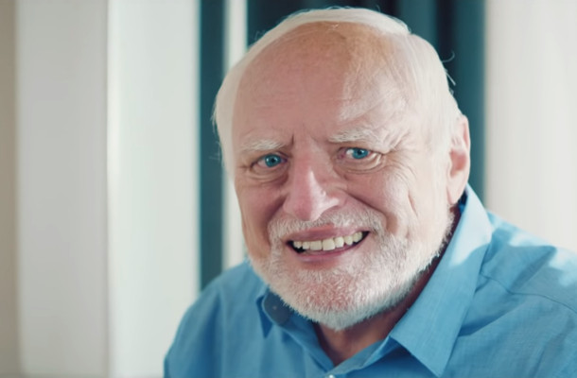

Harold

Age: 50 – 55 (52)

Transportation to Island: Air

# of people in party: 1

Accommodations: Private Condo

Interested in local attractions: yes

Annual income: 175,000

Purpose of trip: Vacation

Country of Origin: Germany

Length of stay (in days): 14

Visit status: Repeat

Island transportation: Rental Car

C:

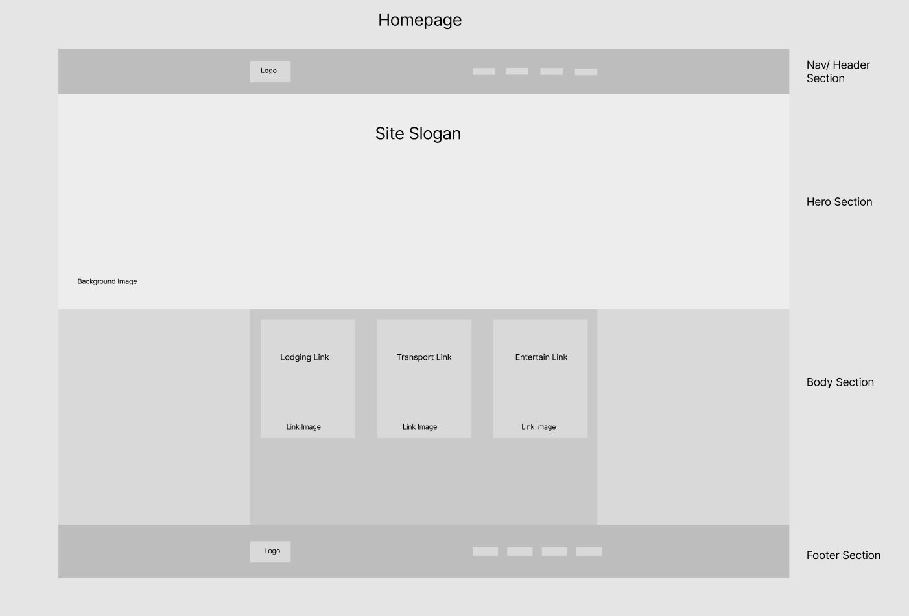

D1:

Steve

* Qualitative feedback: Images below main header image not clear as clickable links
  + Actionable: Make mouse over effects as well as change the curser to a pointer
* Qualitative feedback: Clicking the logo in the header and footer sections does not take user back to homepage
  + Actionable: Make logo take user back to homepage and include mouse over pointer to let user know the logo icon does something.
* Qualitative feedback: The FAQ section has a good amount of information about the island
  + Unactionable: nothing needs to be done.

Amy

* Qualitative feedback: Images in lodging section does not fully show the area and location of the hotels.
  + Actionable: include links to the lodging business which would have all the information needed about the hotel
* Qualitative feedback: Great images and information about the local beaches
  + Unactionable: no action needed.
* Qualitative feedback: FAQ section does not include regulated smoking and non smoking sections as well as minor rules and regulations for public etiquette.
  + Actionable: Add as much local general knowledge to the FAQ section such as smoking rules for both tobacco and other such smoking things….. and rules for pets around the island.

Tom

* Qualitative feedback: Nowhere on the site explains the rules for public drinking.
  + Actionable: Drinking rules can be added to the FAQ section.
* Qualitative feedback: There is no general website information about beach camping/ driving on the beach.
  + Unactionable: All rules about beach camping is regulated to the type of lodging that is paid for, which would be explained in the hotels personal site. As for beach driving all information about that would be in the FAQ section (typically not allowed)
* Qualitative feedback: Could not find information about permanent living arrangements on the site.
  + Unactionable: The site is based off visiting the island and providing information about lodging for a vacation or business type scenario. Permanent living would be a different site which would provide its own living cost functionality.

D2:

Steve’s feedback is great for all user intractable elements in the page. Having a mouse over effect rather it be something along the line of a box shadow animation showing up, a color change in the text and or background color of the element itself, and including the mouse icon change to the expected hand pointer icon which for the most part is universal for letting the user know the area can be clicked.

Amy’s feedback is a good reminder to add as much information to the FAQ section as possible, even things the creator of the site might not think of. For example if the creator of the side is a non-smoker, it is a good idea to not forget the requirements of those who do smoke. In addition, having all participating hotels and lodging establishments’ web site links available for users to gather more information about their potential stay. These things could include walkable attractions and restaurants.

Toms feedback is another example of things that should be added to the FAQ that the creator might not know or think of. For example the beach driving law if there is one, if that information is not provided from the people wanting the site created, the creator might not think to ask about such a law or rule. This can be extended to public drinking and other open beverage laws or rules in tourist type areas. The creator might not know to ask such things, hence the importance of Guerrilla Testing.

E:

Prototype link:

F:

Usability Testing

1. Does the homepage box image links take you to the correct webpage?

2. Name the top two restaurants on the island according to Fournier’s.

3. What is the drinking age on the island?

4. Where are the locations for currency exchanging on the island?

5. What is the year round weather look like on the island?

G:

Profile image from section B:

https://lbbonline.com/news/meme-icon-hide-the-pain-harold-becomes-play-the-game-harold-in-german-laptop-ad